|  |
| --- |
|  |
| 新概念 3 册 |
| Lesson26 Wanted: a large biscuit tin |

Book

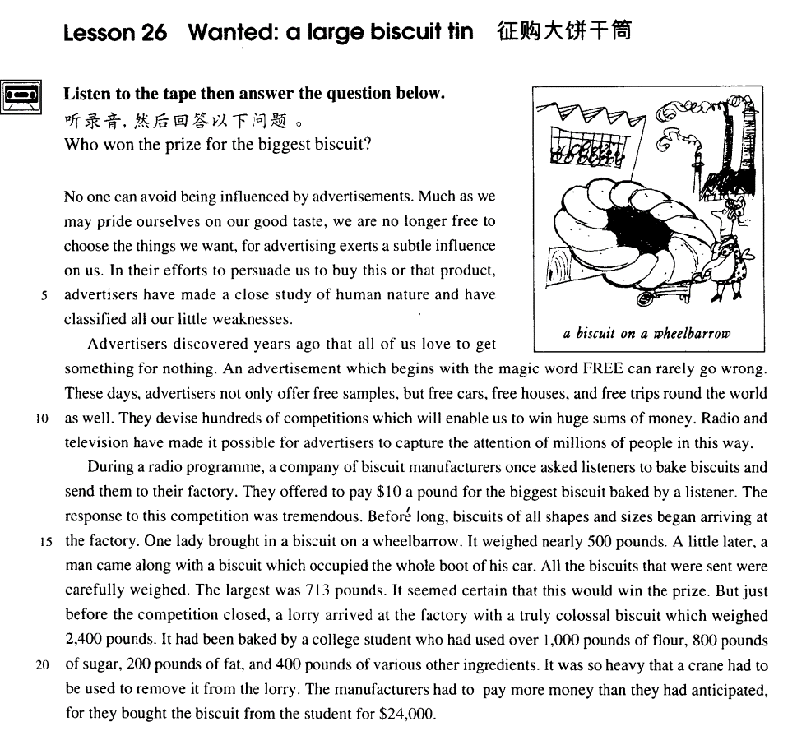

课文

No one can avoid being influenced by advertisements.

没有人能避免受广告的影响。

Much as we may pride ourselves on our good taste, we are no longer free to choose the things we want, for advertising exerts a subtle influence on us.

尽管我们可以自夸自己的鉴赏力如何敏锐，但我们已经无法独立自主地选购自己所需的东西了，这是因为广告在我们身上施加着一种潜移默化的影响。

In their efforts to persuade us to buy this or that product, advertisers have made a close study of human nature and have classified all our little weaknesses.

做广告的人在力图劝说我们买下这种产品或那种产品之前，已经仔细地研究了人的本性，并把人的弱点进行了分类。

Advertisers discovered years ago that all of us love to get something for nothing.

做广告的人们多年前就发现我们大家都喜欢免费得到东西。

An advertisement which begins with the magic word FREE can rarely go wrong.

凡是用“免费”这个神奇的词开头的广告很少会失败的。

These days, advertisers not only offer free samples, but free cars, free houses, and free trips round the world as well.

目前，做广告的人不仅提供免费样品，而且还提供免费汽车，免费住房，免费周游世界。

They devise hundreds of competitions which will enable us to win huge sums of money.

他们设计数以百计的竞赛，竞赛中有人可赢得巨额奖金。

Radio and television have made it possible for advertisers to capture the attention of millions of people in this way.

电台、电视使做广告的人可以用这种手段吸引成百万人的注意力。

During a radio programme, a company of biscuit manufacturers once asked listeners to bake biscuits and send them to their factory.

有一次，在电台播放的节目里，一个生产饼干的公司请听众烘制饼干送到他们的工厂去。

They offered to pay $10 a pound for the biggest biscuit baked by a listener.

他们愿意以每磅10美元的价钱买下由听众烘制的最大的饼干。

The response to this competition was tremendous.

这次竞赛在听众中引起极其热烈的反响。

Before long, biscuits of all shapes and sizes began arriving at the factory.

不久，形状各异，大小不一的饼干陆续送到工厂。

One lady brought in a biscuit on a wheelbarrow.

一位女士用手推车运来一个饼干，

It weighed nearly 500 pounds.

重达500磅左右。

A little later, a man came along with a biscuit which occupied the whole boot of his car.

相隔不一会儿，一个男子也带来一个大饼干，那个饼干把汽车的行李箱挤得满满的。

All the biscuits that were sent were carefully weighed.

凡送来的饼干都仔细地称量。

The largest was 713 pounds. It seemed certain that this would win the prize.

最重的一个达713磅，看来这个饼干获奖无疑了。

But just before the competition closed, a lorry arrived at the factory with a truly colossal biscuit which weighed 2,400 pounds.

但就在竞赛截止时间将到之际，一辆卡车驶进了工厂，运来了一个特大无比、重达2,400磅的饼干。

It had been baked by a college student who had used over 1,000 pounds of flour, 800 pounds of sugar, Two hundred pounds of fat, and four hundred pounds of various other ingredients. It was so heavy that a crane had to be used to remove it from the lorry.

它是由一个大学生烘制的，用去1,000多磅的面粉、800磅食糖、200磅动物脂肪及400磅其他各种原料。饼干份量太重了，用了一台起重机才把它从卡车上卸下。

The manufacturers had to pay more money than they had anticipated, for they bought the biscuit from the student for $24,000.

饼干公司不得不付出比他们预计多得多的钱，因为为买下那学生烘制的饼干他们支付了24,000美元。

词汇讲解

* **influence** ['ɪnflʊəns] n. 影响

**the influence of … on / upon …** …对于…的影响

* the **influence of parents on / upon** their children

**the effect of … on / upon …** …对于…的影响

* the **effect of fertilizers on / upon** the crops

**the impact of … on / upon …**

* the **impact of the oil spill on / upon** marine life
* **pride** [praɪd] v. 骄傲

**be proud of …** （形容词）

**take pride in …** （名词）

**pride oneself on …** （动词）

* **taste** [teɪst] （不可数）n. 鉴赏力，品味
* **老友记**
* Phoebe: Oh that’s good, I guess she’ll have a choice between my guy and your weirdo.
* Chandler: Why would our guy be a weirdo?
* Phoebe: Because that’s just your **taste**.

**a man / woman of taste** 一个有品位的男人/女人

**have … taste in …** 有个…的品味

* She **has good taste in** music.
* He **has terrible taste in** clothing.

**tasteless** 没品味

* **exert** [ɪɡ'zɜ:t]v. 施加

**exert … on …** 对…施加…

* My wife **exerts** a lot of pressure **on** me to make more money.
* …, for advertising **exerts** a subtle influence **on** us.
* Antique shops **exert** a peculiar fascination **on** a great many people.

**impose sth. on sb.** 对某人强加

* Some parents **impose** **their own moral values** **on** **their children**.

**inflict sth. on sb.** 把令人痛苦的事情强加的某人身上

* Please don’t **inflict** your love **on** me.
* **devise** [dɪ'vaɪz] v. 设计，想出
* The cartoon character Mickey Mouse was **devised** by Walt Disney in 1928.

**conceive** ***vi.*** 怀孕；设想；考虑 ***vt.*** 怀孕；构思；以为；持有

**come up with** 想出来

* **托福听力真题：**

A．Very few people come to it.

B．A good name hasn’t been found for it.

C．People don’t like climbing the stairs to get there.

D．She has decided to phone the ticket office.

* M: What had they decided to call the stadium?
* W: Noone has **come up with** a good name.
* Q: What does the woman say about the stadium?
* Answer: (B) A good name hasn’t been found for it.

课文讲解

# （题目）

# Wanted: a large biscuit tin

**wanted:** 诚聘, 求购

* help **wanted** section 招聘启事
* **托福听力真题：**

A．He wants help improving his vocabulary.

B．He plans to read the entire newspaper.

C．He rarely has time to read the newspaper on Sunday.

D．He's interested in finding a job.

* W: Since when do you read the Sunday Times?
* M: Since I discovered its big help-**wanted** section.
* Q: What can be assumed about the man?
* Answer: (D) He's interested in finding a job.

**wanted: *adj.*** 受通缉的；被征求的



* The fugitive is **wanted** by the police.

# （第一段）

# No one can avoid being influenced by advertisements.

知识点（1）

**avoid** v. 躲避，避免

**avoid sb. like the plague** 躲某人像躲瘟疫一样

**avoid doing** 避免做某事

* **造句1**：没有人可以避免受到社会的影响。
* No one can **avoid being** influenced by society.
* **造句2**：没有人可以避免受到金钱的引诱。
* No one can **avoid being** tempted by money.
* **造句3**：没有人可以避免犯错误。
* No one can **avoid making** mistakes.

知识点（2）

**语法**：双重否定，加强语气

* No one can avoid being influenced by advertisements. 双重否定，加强语气
* Everyone is influenced by advertisements. 肯定表达
* Everyone admits that … 肯定表达
* No one can deny that … 双重否定，加强语气
* Everyone is attracted by … 肯定表达
* No one can resist …双重否定，加强语气

# Much as we may pride ourselves on our good taste, we are no longer free to choose the things we want, for advertising exerts a subtle influence on us.

Much as we may pride ourselves on our good taste（让步状语从句）, we are no longer free to choose the things we want（主句）, *for advertising exerts a subtle influence on us*.（原因状语从句）

知识点（1）

**pride oneself on ...** 对…很自豪

**take pride in ...**

**be proud of ...**

知识点（2）

**语法：**强调句；让步状语从句中，把被强调的词放到句首；书面语

* **Although** we may **much** pride ourselves on our good taste,
* ... **Much *as*** *（强调much）*we may pride ourselves on our good taste, …
* **（副词的强调句）**
* **Although** I **much** admire Newton as a scientist, I don’t like him as a man.
* **Much *as***I admire Newton as a scientist, I don’t like him as a man.
* **（形容词的强调句）**
* **Although** we may be **proud** of our good taste,
* ... **Proud** ***as*** we may be of our good taste, ...
* **（形容词的强调句）**
* **Although** she is **beautiful**, I still don’t like her.
* **Beautiful** ***as***she is, I still don’t like her. （形容词的强调句）
* **（动词的强调句；动词原形放在句首，原来的位置用助动词代替）**
* **Although** he **tries**, he never seems able to do the work beautifully.
* **Try *as***he does, he never seems to do the work beautifully.
* **（名词的强调句；名词前的冠词去掉，名字放在句首）**
* **Although** he is a **child**, he can make a living.
* **Child *as***he is, he can make a living.

知识点（3）

**be free to do …** 自由的做某事

* You **are free to choose** the things you want.

**freely**

* You can choose the things you want **freely**.

**be at liberty to do** 自由的做某事

* You **are at liberty to choose** the things you want.

知识点（4）

advertising 广告宣传，不可数

# In their efforts to persuade us to buy this or that product, advertisers have made a close study of human nature and have classified all our little weaknesses.

In their efforts to persuade us to buy this or that product（时间状语）, advertisers have made a close study of human nature and have classified all our little weaknesses.

知识点（1）

**in sth. / doing** 在…的过程之中

* **In trying** to persuade us to buy …
* **In seeking** independence, they do not sacrifice their human dignity.

知识点（2）

**persuade sb. to do / into doing** 说服某人做某事

**talk sb. into doing** 说服某人做某事

* We **talked** Father **into** buying the car.

**get sb. to do** 说服某人做某事

* The rough road across the plain soon became so bad that we tried to **get** Bruce **to** drive back to the village we had come from.

表达“**说服某人不要做某事**”:

**persuade sb. not to do / out of doing**

**talk sb. out of doing**

**get sb. not to do**

**dissuade sb. from doing**

* **造句**：我劝他不要自杀 (commit suicide)
* I **persuaded** him **not to commit** / **out of committing** suicide.
* I **talked** him **out of committing** suicide.
* I **got** him **not to** commit suicide.
* I **dissuaded** him **from** **committing** suicide.

知识点（3）

**this or that product** 这件或哪家商品（各种各样的商品）

**one product or another** 各种各样的商品

**some product or other** 各种各样的商品

* **课后题：**
* 9. in their efforts to persuade us to buy___C___ (1.4)

(a) one or other product (b) that or this product

(c) some product or other (d) a product or two

知识点（4）

**study …** v.研究

**make a study of ...** 做研究

**make a *close* study of …**

* Recently the New York Animal Medical Center **made a study of** 132 cats over a period of five months.

**discover** 发现

**make an *interesting* discovery of …** 做出（有趣的）发现…

* Some time ago, **an interesting discovery was made** by archaeologists on the Aegean island of Kea.

**describe** 描述

**make a *vivid* description of …** 做出（生动的）描述

**investigate** 调查

**make a *thorough* investigation of …** 做（深入的）调查

**summarize** 总结

make a *comprehensive* summary of… 做出（全面的）总结

**analyze** 分析

**make a *detailed* analysis of …** 做出（细致的）分析

知识点（5）

**weakness** 1. （不可数）懦弱, 软弱 2.（可数）弱点

* So let us begin anew —remembering on both sides that civility is not a sign of **weakness**, and sincerity is always subject to proof. Let us never negotiate out of fear, but let us never fear to negotiate. — John F. Kennedy

**反义: strength 优点, 长处 [C]**

**strengths and weaknesses**

* For we know that our patchwork heritage is a **strength**, not a **weakness**. We are a nation of Christians and Muslims, Jews and Hindus, and nonbelievers.

# （第二段）

# Advertisers discovered years ago that all of us love to get something for nothing.

Advertisers discovered years ago（时间状语，前置） that all of us love to get something for nothing. （及物动词后，如果宾语长状语短，先写状语后写宾语）

知识点（1）

**for nothing / for free / free of charge** adv. 免费……

* Guests can park **for nothing / for free / free of charge.** 免费停车

**no charge for … ……**免费

* There is **no charge fo**r parking.

**be on the house** 店主请客

* **走遍美国**
* How much do I owe you?
* Well, that'll be eighteen dollars and seventy cents. **No charge for** the cleanup. **It's on the house.**

# An advertisement which begins with the magic word FREE can rarely go wrong.

An advertisement *which begins with the magic word FREE* （定语从句）can rarely go wrong.

知识点（1）

**begin with …** 用…来开始

* **走遍美国**
* Let’s go into the kitchen, and maybe you can help me set the table.
* *Sounds good to me. What are we having?*
* I prepared lamb chops, mashed potatoes, and a tossed green salad to **begin with.**
* *Grandpa, you are a terrific guy!*

**end with …** 用…来结束

* The rally **ended** **with** the singing of national anthem.

知识点（2）

**go wrong** 出错，出问题，不顺利

* Something’s **gone wrong** with my computer.
* We have all experienced days when everything **goes wrong**.

# These days, advertisers not only offer free samples, but free cars, free houses, and free trips round the world as well.

**round / around the world** 遍及世界

**throughout the world** 遍及世界

**all over the world** 遍及世界

**the world over** 世界各地

# They devise hundreds of competitions which will enable us to win huge sums of money.

**enable sb. to do ...** 是某人能做某事

**make it possible for sb. to do ...** 是某人能做某事成为可能

* Radio and television have **made it possible for** advertisers **to** capture the attention of millions of people in this way.

# Radio and television have enabled advertisers to capture the attention of millions of people in this way.

**capture / attract / draw / catch / arrest / command / get + *(one’s) attention / the attention of …*** *吸引了…的注意力*

* This **attracted the attention of** Richard Humphries who was then the most eminent boxer in England.
* True eccentrics never deliberately set out to **draw attention** to themselves.

# （第三段）

# During a radio programme, a company of biscuit manufacturers once asked listeners to bake biscuits and send them to their factory.

**bake** 烤（素）

**baker** 面包师

**baker’s / bakery** 面包房

**roast** 烤（肉）

* **roast** turkey
* **Peking** roast duck

**grill / broil** 烤（明火）

* **grilled / broiled** chicken barbecue

**BBQ** 野外烧烤

# They offered to pay $10 a pound for the biggest biscuit baked by a listener.

for 等价交换

* She paid me $30 **for** my bike.
* She bought my bike **for** $30.
* Advertisers discovered years ago that all of us love to get something **for** nothing.
* The manufacturers had to pay more money than they had anticipated, for they bought the biscuit from the student **for** $24,000.

# The response to this competition was tremendous.

**the response to … is / was tremendous / lukewarm …**反响很剧烈/平淡

* In 1908 Lord Northcliffe offered a prize of ₤1,000 to the first man who would fly across the English Channel.
* 造句：学校提供了一笔 1000 美元的奖金给第一个能解决这个问题的学生。大家对这次比赛的反应很热烈/很平淡。
* The university offered a prize of $1,000 to the first student who would find a solution to the problem. **The response to the competition was tremendous / lukewarm.**

# Before long, biscuits of all shapes and sizes began arriving at the factory.

知识点（1）

**before (very / too) long** 不就之后

**before much longer**

**shortly afterwards**

* **Shortly afterwards**, the police stopped the car and both men were arrested.

**a little later** 不就之后

* **A little later**, a man came along with a biscuit which occupied the whole boot of his car.

**after a *little / short* time / while** 不就之后

* **After a little time**, she chose one of the most expensive dresses in the shop and handed it to an assistant who wrapped it up for her as quickly as possible.

知识点（2）

**all sorts / kinds / types of sth.** 各种各样的

* He added that a student had dressed up as a policeman and was playing **all sorts of silly jokes** on people.
* **造句**：她每天必须要处理各种各样的投诉。
* She has to deal with **all kinds of complaints** every day.

# One lady brought in a biscuit on a wheelbarrow.

# It weighed nearly 500 pounds.

**weigh …** 系动词，有多重

* The boy **weighs** 50 kilos.

**be … (in weight)** 有多重

* The boy **is** 50 kilos **(in weight).**

**be / stand … high / tall** 有多高

* She **stood** （系统词）three feet high and her hands rested on her hips.
* He **stands** / **is** 1.8m tall.

**rise to a height of …** 高达

* Above the surface of the water, the towers **rise to a height of** nearly 700 feet.

**be … deep / in depth** 有多深

* The hole **is** 2 feet **deep / in depth.**

**extend to a depth of …** 深达

* The platforms **extend to a depth of** over 100 feet under the sea.

**be … long / in length** 有多长

* The bed **is** 2 meters **long / in length.**

**be … wide / across / in width** 有多宽

* The river **is** 20 meters **wide / across / in width**.

# A little later, a man came along with a biscuit which occupied the whole boot of his car.

**along with …** 与…在一起

* Mr. Taylor, **along with** two assistants, ***is***trying to stop the thieves.

**along with**

**together with ...** 在一起的…

**coupled with ...** 再加上…

**accompanied by ...** 被…陪伴着

**followed by ...** 还跟着…

**besides ...** 除了…

**as well as ...** 除了…之外

**no less than ...** …也

**including ...** 还包含…

(**修饰主语，主语是单数，谓语动词用单数**)

# All the biscuits that were sent were carefully weighed.

# The largest was 713 pounds. It seemed certain that this would win the prize.

* **替换写法：**
* The largest **was** 713 pounds **(in weight).**
* The largest **weighed** 713 pounds.

# But just before the competition closed, a lorry arrived at the factory with a truly colossal biscuit which weighed 2,400 pounds.

But just before the competition closed（时间状语）, a lorry arrived at the factory *with a truly colossal biscuit which weighed 2400 pounds*.（伴随状语）

# It had been baked by a college student who had used over 1,000 pounds of flour, 800 pounds of sugar, Two hundred pounds of fat, and four hundred pounds of various other ingredients.

# It was so heavy that a crane had to be used to remove it from the lorry.

* **造句**：箱子太沉了，用了一辆卡车才把它运到目的地。
* The box was so heavy that a lorry had to be used to carry it to the destination.
* **造句**：两年多来这条街上新开了很多商店。
* In the past two years many shops have been set up in the street.
* **英译汉：**
* A new government was organized after the war.
* 战后成立了新政府。

# The manufacturers had to pay more money than they had anticipated, for they bought the biscuit from the student for $24,000.